Company Name: ECSquared

Address: 1801 Forrest Rd,

Wilmington DE, 19810

Technical Point Of Contact: Edward Crowder,

Cell: 302-750-8554

Email: [ecrowder@ecsquared.net](mailto:ecrowder@ecsquared.net)

The Petal Concept, A Bio-Solar Innovation

The Air Force is working towards a more robust energy profile, one part of this push will need to be renewable, green, sources. The Petal Concept is a novel idea to develop a solar power that combines a biological component with nano technology to create a bio-solar power. We, and the University of Delaware, have been awarded a STTR, AF192, to develop Air Force partners and advance the concept.

Project Description, Innovation and Impact:

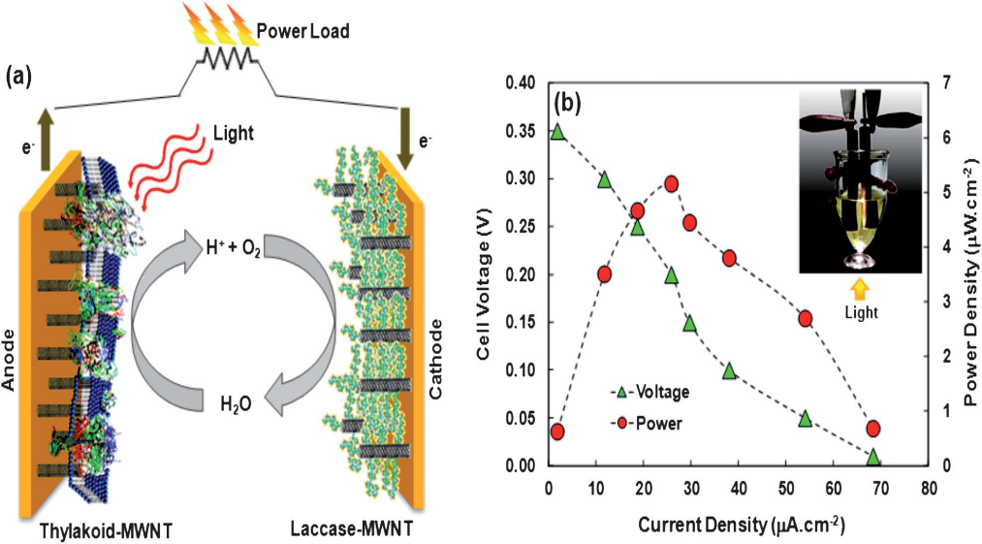The Petal Concept is a modular technology to generate solar-powered electricity at the point-of-use by integrating photosynthetic proteins with electrical components. The Petal Concept utilizes the photosynthetic protein Photosystem II (PSII) from plant or bioreactor in conjunction with carbon nanotubes (CNT) to create an inexpensive, electron-generating hybrid system. These components are applied to a flexible, conductive substrate/membrane to produce bio-solar power. This malleable coating can be scaled from nano, to micro to grid level applications.

Plant is used because its growth is well understood, it is non-fibrous which eases purification and future genetic manipulation is possible to increase the amount of PSII protein produced and/or adding a functional attachment loci. Expression of recombinant PSII using E. Coli in bioreactors is a likely methodology to increase yields and reproducibility of production. PSII is used due to its ability to split the water molecules to liberate electrons, thus creating current. A good basic understanding of the protein exists, however additional work is needed to fully understand its form, sequence, action to split water and electron transport. It is also needed to validate that the protein will act when not in its’ native membrane. Work is also needed to understand optimal light levels and protein lifespan. Carbon nanotubes (CNTs) are used because of their excellent conducting properties and the ability to attach proteins. Additional work is required to improve the protein attachment process to ensure correct protein orientation and functionality. Work is also required to allow for rapid removal and replacement of spent protein.

Figure 3: Schematic Overview of the Petal Concept

Relevance and Outcomes:

Preliminary work has developed a bench scale model that generated 20.44 ±1.58 µA/cm2 current using membrane-bound PSII. Further study on Petal would provide deeper understanding of the process and generate a prototype using purified PSII protein. The power target is to achieve a Biosolar “power membrane” capable of continuous power from sunrise to sunset and to quantify the theoretical output at this scale. Scaling goals for the initial work are up to 5 cm2 (or the approximate size of a leaf) in the form of a “power membrane”. The next goals will be 20 cm2 then 100cm2 to see if the skin or “power membrane” can be conformed to any shape while being scaled.

Innovation:

Currently, the electrical circuit has been laid out for a brass board application but will need optimization for individual applications with a focus of supporting conformal applications. Since the subunit is nano-scale it is possible to package and scale for nearly unlimited applications. Whole industries will be able to use and modify the basic concept from nano- to macro-scale uses. Nano-scale uses/technology/projects may power nanobots, micro-scale may power sensors or micro-bots and macro-scale may power UAV’s, watches, phones or anything that currently uses lithium batteries. An ultimate goal may be to create grid scale power generation that could supplement/replace photovoltaics, wind or other renewable power sources and to eliminate the need for fossil fuels.

There are many fundamental questions that must be studied about the basic physics/chemistry of these processes before scaling could be carried out. These questions are unknown but a number of the steps can be inferred from other work. Putting them together is going to be required.

Potential Impact

The Petal Concept advantage is that the model for photosynthesis, plants, has a proven record of success. All life on earth is driven by the photosynthetic process. Additionally, individual portions of the project currently exist; no new materials need to be invented. The innovation lies in combining these existing materials and biologically based processes in new and exciting ways to create a new industry.

Today power feed to the grid comes from hydro sources, wind source, fossil sources, and silicon based solar sources. Grid level deployment of this new technology could speed the way toward a conversion of the national economy to a renewable model. This concept will become fields of green as the power of photosynthesis ushers in the time of greater prosperity and world-leading industries.

Mother nature has taken billions of years to perfect photosynthesis. Now we just need to modify it to our needs and the Petal Concept shows the way.

TEAM QUALIFICATION AND RESOURCES

Project Team’s Unique Qualifications

The team consists of Robert Opila, Edward Crowder, Shuang Liu and Meixi Chen.

Mr. Crowder is the original developer of the Petal concept. Mr. Crowder owns the Patent on the concept, US20120279552A1. His deep understanding of the concept and passion for the idea will drive the project. Dr. Opila and Dr. Chen specialize in advanced solar cell development that emphasizes semiconductor science and surface science including charge transfer in an organic/inorganic hybrid system, interface reactions and light trapping. Dr. Liu has expertise on chemistry, polymer, and biomaterials design including bioconjugation of small molecules, synthetic polymers and biomacromolecules.

Table 2. Roles and time commitment for each team member

|  |  |  |
| --- | --- | --- |
| **Team Member** | **Organization** | **Role** |
| Dr. Robert Opila | UD | PI |
| Edward Crowder | ECSquared | Technical POC |
| Dr. Shuang Liu | UD | Researcher |
| Dr. Meixi Chen | UD | Researcher |

Project Team’s existing Equipment and Facilities

Facilities and equipment for successful completion of the technical effort will be supported by University of Delaware (UD). We will have access to the Delaware Biotechnology Institute (DBI), University of Delaware Nanofabrication Facility (UDNF), Materials Science Department, Department of Chemistry and Biochemistry, College of Engineering, Computational Facilities and University of Pennsylvania Singh Nanofabrication Facility. These facilities provide capability of material testing, structure characterization, device fabrication and simulation.